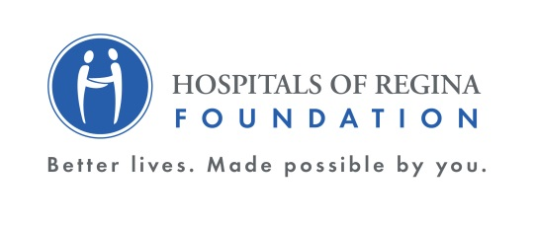
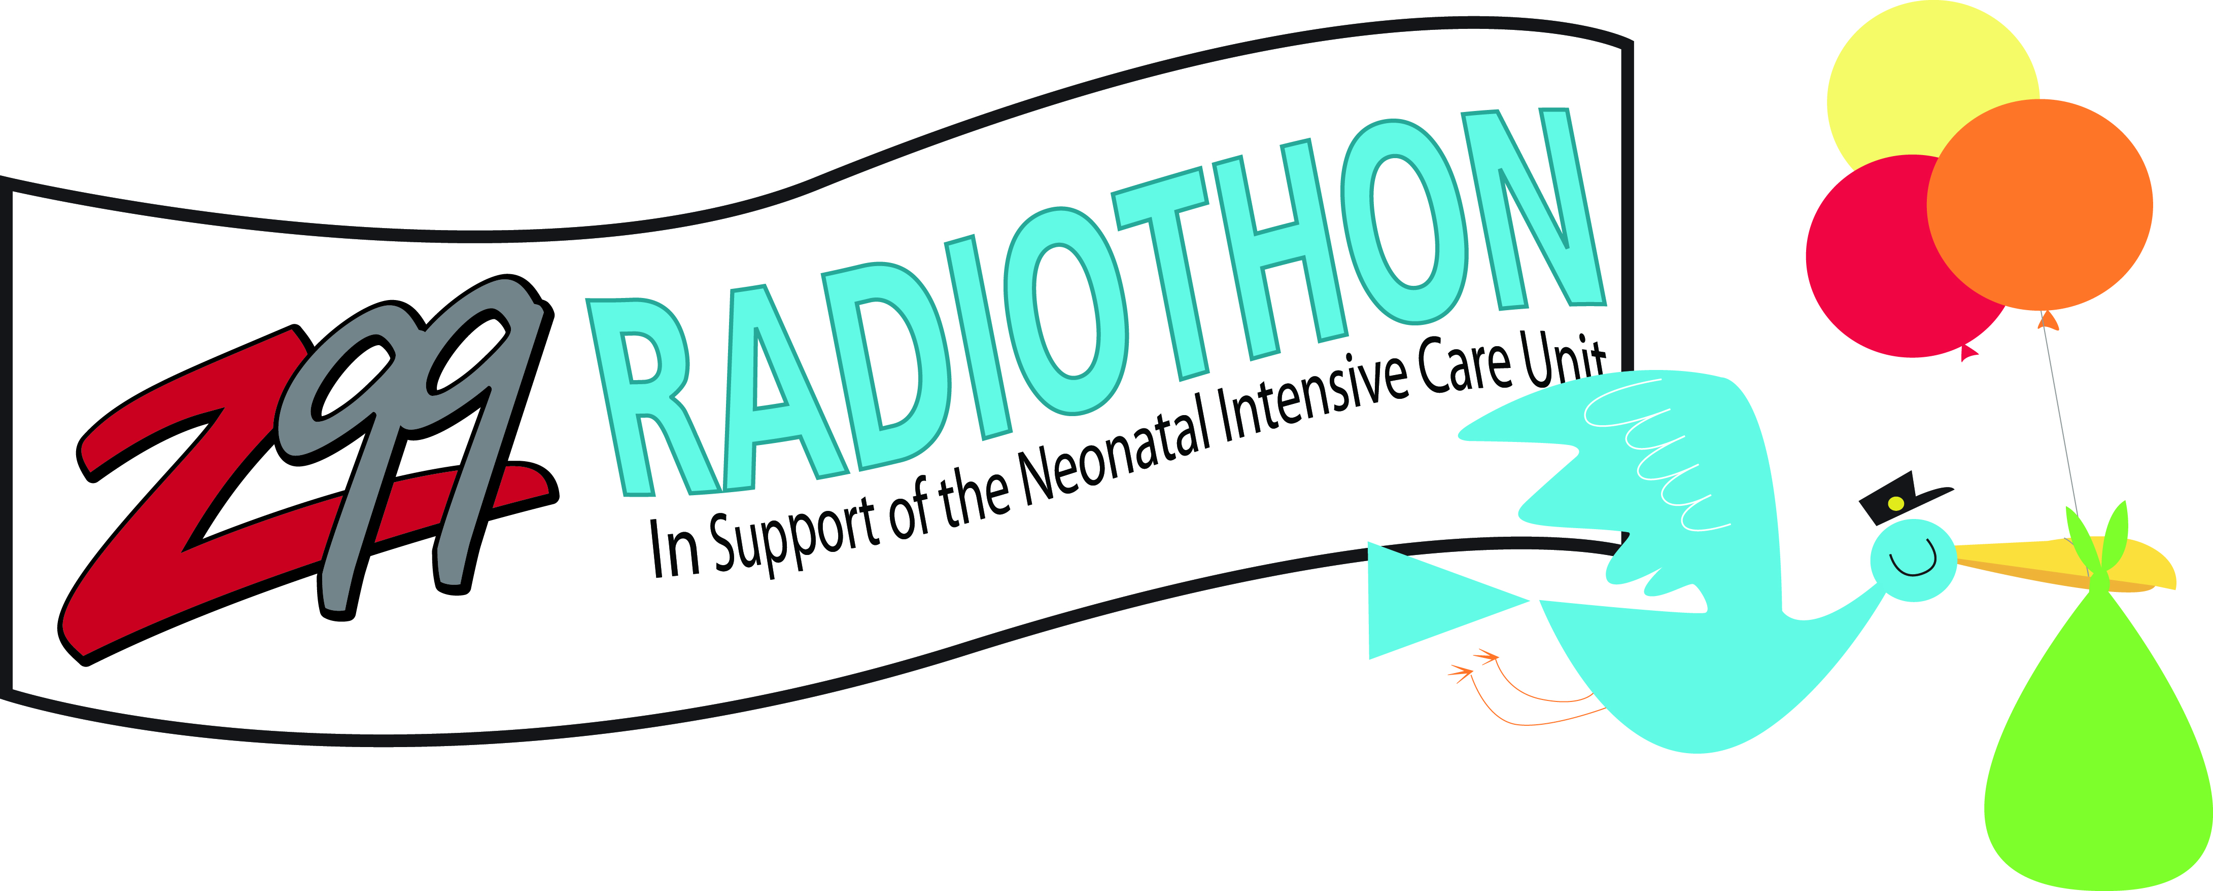
FOR IMMEDIATE RELEASE

Saving Babies’ Lives
31st Annual Z99 Radiothon Raises $718,243

Mar. 16, 2018, Regina, Saskatchewan – As Rawlco Radio celebrates its 30th anniversary, Z99’s hosts CC, Lorie and Cassity hit the airwaves on March 15 and 16 for the 31st annual Z99 Radiothon. For 36 continuous hours the dynamic trio encouraged people to help save babies’ lives. Thanks to overwhelming community support the Radiothon raised $718,243 for the Hospitals of Regina Foundation (HRF) in support of the Neonatal Intensive Care Unit (NICU), located in the Regina General Hospital. That brings the fundraiser’s 31-year total to more than $ 8.5million for babies in need.

“When it comes to the health of newborns, the importance of the NICU cannot be overstated for the hundreds of families that need immediate, critical care,” says Tom Sorenson, manager of the NICU. “Thanks to the support of Rawlco Radio and everyone that donated, Hospitals of Regina Foundation can continue to invest in the best care available for vulnerable babies.”

“We can’t say enough about the commitment and support our Radiothon has received over the past 30 years,” says Tom Newton, vice president and general manager, Rawlco Radio. “Our on-air team has worked tirelessly to encourage the community to donate and they responded with great generosity. We are proud to have helped make such an impact on the many babies requiring Regina’s NICU.”

President and CEO, HRF, Dino Sophocleous says, “Never underestimate the giving spirit of this community. We are touched by the outpouring of generosity we saw not only these past two days but over the 30 years that the Foundation has operated. Through this fundraiser, our community has demonstrated, once again, a strong commitment to improved health care today and better lives tomorrow. We can’t say thank you enough to Rawlco Radio, the Z99 team and our community.”
ABOUT THE CAUSE
Over the past 31 years, the Z99 Radiothon has raised more than $8.5 million for the Neonatal Intensive Care Unit (NICU), located in the Rawlco Centre for Mother Baby Care. Through generous community support, the Radiothon has provided the NICU with leading edge, life-saving technology that has enhanced the staff’s ability to care for fragile newborns.
The NICU is located in the Rawlco Centre for Mother Baby Care at the Regina General Hospital. Approximately 500 babies from 24 to 42 weeks old require care in the unit each year. The NICU, which also includes the special care nursery for babies who require less intensive care, has capacity for 29 babies. On average, 21 babies a day require care in the unit.
ABOUT HRF
In 1987, an inspired group of volunteers came together to make better lives for the people of southern Saskatchewan by establishing Hospitals of Regina Foundation. As we celebrate our 30th anniversary, we wish to thank you for your unwavering support, generosity and dedication to enhancing the lives of people you care about in our community. Your on-going support will mean ever-improving health care for people needing Regina’s hospitals, across southern Saskatchewan.
-30-
For more information, contact:
Amber Morse Bonnie Monteith
Promotions Director, Z99 Director, Marketing & Communications
Rawlco Radio, Ltd. [Regina] Hospitals of Regina Foundation
(306) 525-0000 (306) 781-7520
amorse@rawlco.com bonnie.monteith@hrf.sk.ca
Visit our new website for more information www.hrf.sk.ca.

